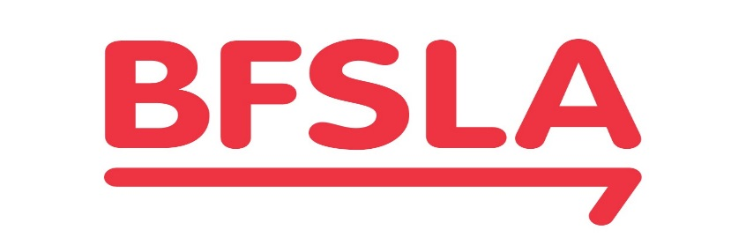
THE BANKING AND FINANCIAL SERVICES LAW ASSOCIATION LTD
ACN 006 354 089

2024 RESEARCH ESSAY COMPETITION

PRIZE POOL OF A$10,000

You may be able to win one of Australia and New Zealand’s most prestigious prizes for legal research essays.

Each year, the Banking and Financial Services Law Association (BFSLA) invites citizens and permanent residents of Australia and New Zealand to submit research essays on important matters in banking and financial services (including insolvency) law and/or practice that are currently topical in Australia or New Zealand, in competition for a prize pool.

The BFSLA is the leading professional organisation for banking and financial services law in Australia and New Zealand. The BFSLA’s objects include the pursuit and dissemination of knowledge of banking and financial services law and practice in Australia and New Zealand, including by encouraging research.

The prize pool in 2024 is A$10,000.

Entries must be submitted by 5pm (Australian Eastern Standard Time) on Friday, 26 July 2024. The winner or winners, if any, will be announced by publication on the Association’s website on or about Friday, 30 August 2024.

To be eligible, entries need to display a high degree of legal scholarship and original thinking, and to be of a standard, as regards both content and presentation, that is suitable for publication in a refereed law journal.

Eligible entries will be judged by an adjudication panel of highly qualified individuals selected by the Board of the BFSLA, chaired by a member of the Board. In the past the panel has included senior judges, academics, and practitioners (in-house and private practice), from Australia and New Zealand. The panel will make recommendation(s) to the Board, but the Board reserves the right to make the final decision.

Essays which (or a substantial part of which) have previously been submitted for assessment as part of tertiary studies are welcome, but we will require certain information and authority to check that the author of both works is the same person.

For a full list of conditions, more information about the prize and an explanation of how to enter, go to the Association’s website, https://bfsla.org/2024-research-essay-prize/

If you have any other questions about the prize, please email Julia Clancy at 2024researchprize@bfsla.org

