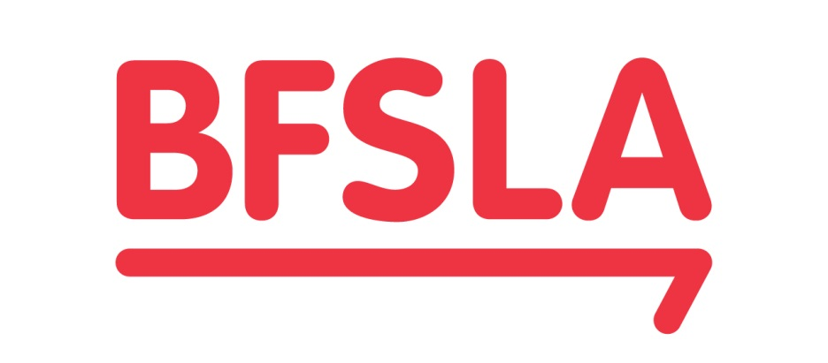
THE BANKING AND FINANCIAL SERVICES LAW ASSOCIATION LTD
ACN 006 354 089

2024 SCHOLARSHIP

UP TO A$50,000
The Banking and Financial Services Law Association is the leading industry organisation for banking and financial services law in Australia and New Zealand and since 1993 has been supporting people to fulfil their ambition of undertaking post-graduate study in banking & finance and insolvency law at some of the world’s most prestigious universities.

TERMS AND CONDITIONS
Objectives
The BFSLA offers a scholarship to support Australian and New Zealand citizens and permanent residents in undertaking post-graduate study at an internationally recognised university in furtherance of its objective of fostering and sharing knowledge about banking and financial services law and practice in Australia, New Zealand and abroad.
Eligibility
To be eligible for the BFSLA 2024 scholarship, an applicant must:
- Be a citizen or permanent resident of Australia or New Zealand
- Have been accepted into, or currently studying at, an internationally recognised university outside of their country of citizenship and country of permanent residence
- Have completed their LLB or JD degree at an Australian or New Zealand university prior to commencing their post-graduate study
- Commence (or continue) their post-graduate study in 2024
Additionally, an applicant is ineligible if:
- They have, or will have, completed their post-graduate study at the time the scholarship is announced
- They have previously been awarded the BFSLA scholarship
- They are a director of the BFSLA or a member of the 2024 Scholarship Committee
Applications
Application forms: Applications must be submitted using the 2024 Scholarship application form and include all additional material specified in the form. Incomplete or unsigned applications will not be considered. Application forms are available on the BFSLA website.
References: The BFSLA will seek written references from the three referees nominated by the applicant but it reserves the right also to contact other persons whom it reasonably believes may know the applicant. Any contact with referees or other persons will be made on a confidential basis and each applicant consents to the BFSLA doing so and disclosing information contained in the application to them.
Clarification: The BFSLA may contact applicants to clarify anything in their application.
Scholarship
Amount: The scholarship is for an amount of up to A$50,000 to assist with the costs of tuition, living expenses and related travel.
More than one scholarship: The BFSLA may award more than one scholarship. Where there is more than one successful applicant, the BFSLA board will decide the amount each applicant receives in its discretion.
No scholarship: The BFSLA reserves the right not to award any scholarship in 2024.
Payment: The scholarship amount will be paid to successful applicants in two instalments: first, upon the award of the scholarship and second, upon completion of the studies identified in the successful applicant’s application or at the end of the academic year if the post-graduate study is for longer than one year. The instalments will be of equal amounts unless otherwise agreed by the BFSLA board.
Forfeiture: The successful applicant may forfeit any unpaid instalment of the scholarship amount if they change their course of study from that outlined in their application in a way that the BFSLA reasonably considers is not consistent with the objectives of the scholarship.
Report: The successful applicant will be required to provide two written reports to the BFSLA board during the course of their studies outlining how their studies are progressing, personal observations on living and studying overseas and their highlights to date. The first report should be submitted by the end of January and the second report at the end of the academic year. The successful applicant consents to these reports being published on the BFSLA’s website.
Decision
Scholarship Committee: The BFSLA board will appoint a scholarship committee to review applications and make a recommendation to the board on the award of the 2024 scholarship (including whether to award more than one scholarship or not to award a scholarship).
Board: The final decision of the 2024 scholarship will be made by the BFSLA board. The board will consider the recommendation made by the scholarship committee and any other criteria the board considers appropriate, including the value of the proposed study.
Announcement: The outcome of the 2024 scholarship will be publicly announced after 30 June 2024. Details of the outcome will also be posted on the BFSLA’s website. The BFSLA reserves the right to publicise the outcome in other ways.

